ProjectDevelopmentPhaseModelPerformanceTest

|  |  |
| --- | --- |
| Date | 22September2023 |
| TeamID | NM2023TMID05015 |
| ProjectName | GlobeTrek Insights:NavigatingGlobalCountry  DataWithIBMCognos |
| MaximumMarks | 10Marks |

**ModelPerformanceTesting:**

Projectteamshallfillthefollowinginformationinmodelperformancetestingtemplate.

|  |  |  |
| --- | --- | --- |
| **S.No.** | **Parameter** | **Screenshot/Values** |
| 1. | Dashboarddesign | NoofVisualizations/Graphs– |

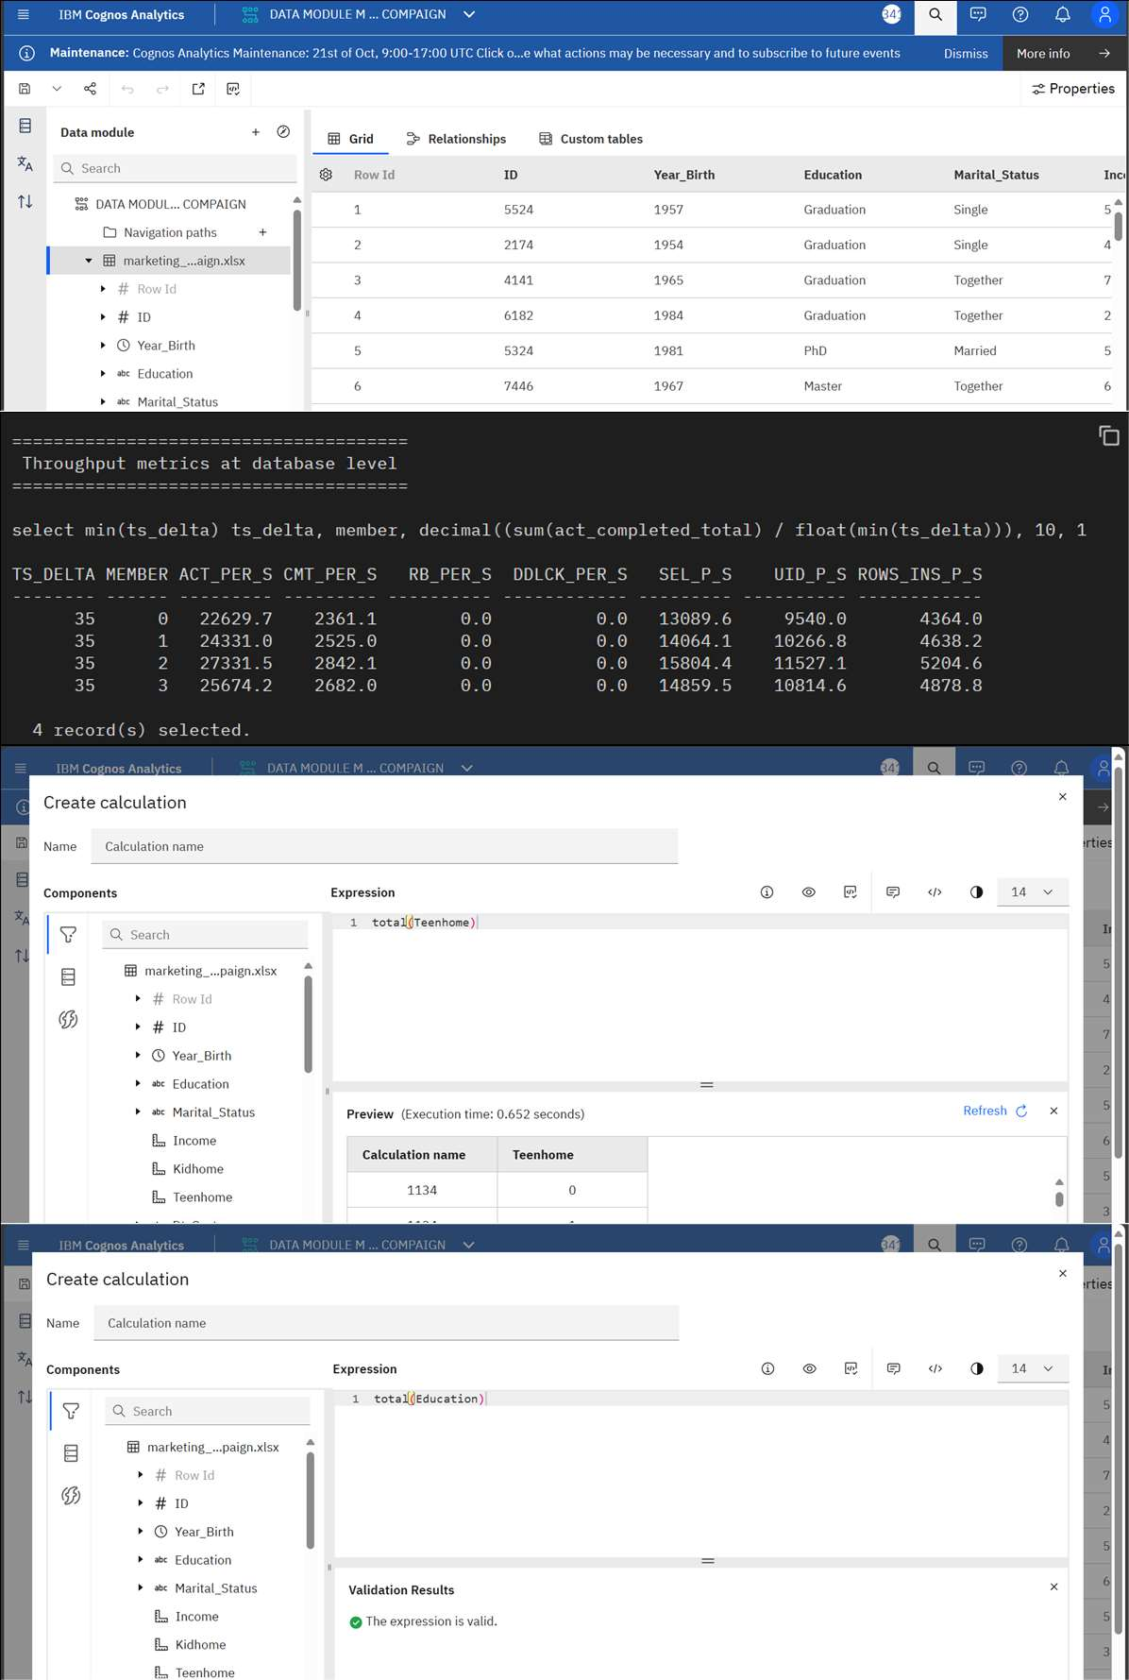

|  |  |  |
| --- | --- | --- |
| 2. | DataResponsiveness |  |

|  |  |  |
| --- | --- | --- |
| 3. | AmountData  toRendered(DB2Metrics) |  |



|  |  |  |
| --- | --- | --- |
| 4. | Utilizationof  DataFilters |  |



|  |  |  |
| --- | --- | --- |
| 5. | EffectiveUserStory | NoofSceneAdded– |

|  |  |  |
| --- | --- | --- |
|  |  |  |
| 6. | DescriptiveReports | NoofVisulizations/Graphs– |

|  |  |  |
| --- | --- | --- |
|  |  |  |